**MATHEMATICS SPECIALIST UNIT 3&4 Name_______________**

**TEST 5, 2016**

You must show all working

**Section One: Resource Free**

Reading Time: 2 minutes Working Time: 21 minutes Total marks: 21 ________________________________________________________________________________________

**Question 1 (8 marks)**

Determine a general solution to the following differential equations:

(a)  (2 marks)

(b) = (2 marks)

(c) = (4 marks)

Question 2 (6 marks)

A cinema photographer is wishing to keep track of an elevator (lift) which is moving at 3 m/s vertically upwards on the outside of a building. The camera positioned on the ground 30m from the base of the building. Calculate the rate of change of the angle of elevation of the line of sight of the camera when the lift is 40m from the ground.

Question 3 (4 marks)

Find the equation of the tangent to the curve  at the point 

**Question 4 (3 marks)**



(ii).



(iv):



(i)

. 

(iii):



**MATHEMATICS SPECIALIST UNIT 3&4 Name_______________**

**TEST 5, 2016**

You must show all working

**Section One: Resource Rich**

Reading Time: 3 minutes Working Time: 27 minutes Total marks: 27 ________________________________________________________________________________________

**Question 5 (5 marks)**

A radioactive substance has a half-life of 18 years. That is, it takes 18 years for 50% of any given amount of this substance to decay.

(a) Given that,  = *kA*, find the value of *k* and write an exponential equation that relates *A* and *t*, where *A* is the amount of the substance remaining after *t* years. (3 marks)

(b) Hence, find the time, to the nearest year, taken for 90% of a given amount of the substance to decay. (2 marks)

Total marks: ________________________________________________________________________________________

Question 6 (7 marks)

The graph of  is shown below.

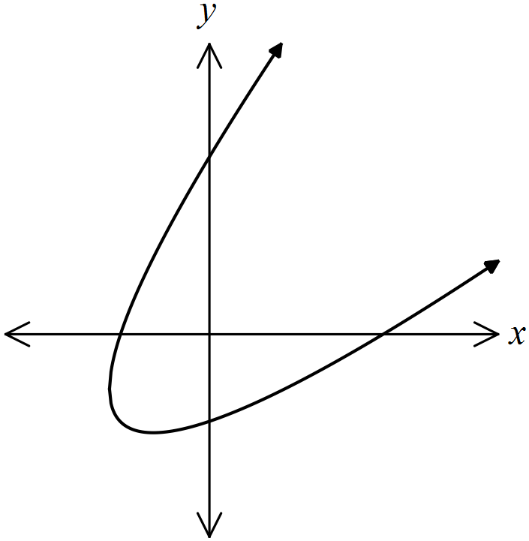

(a) Determine the coordinates of all axes intercepts. (2 marks)

(b) Show that the gradient at any point on the curve is given by . (3 marks)

(c) Determine the equation of the tangent to the curve at the point where the curve intersects the positive y-axis. (2 marks)

Question 7 (7 marks)

Assuming that the rate of cooling of a body is proportional to the temperature difference between the body and the medium it is contained in is given by the differential equation



where T° K is the temperature of the body and t is the time in minutes.

(a) If the original temperature of the body is T = 150° K, the surrounding medium is

100° K, use the above constraints to show that the equation for the temperature of the body is

T(t) = 100 + 50e-kt where t is in minutes and T is in °K (3 marks)

(b) Given that the body cools to 135° K in 10 minutes evaluate k to 4 d.p. (2 marks)

(c) What is the temperature after 20 minutes? (1 mark)

(d) How long, to the nearest minute, will it take for the body to cool to 120° K?

(1 marks)

**Question 8 (8 marks)**

A farmer stocked his lake with 400 fish. The farmer sought some advice and found the lake was thought to have a carrying capacity of 3000 fish.

The number of fish quadrupled in the first year.

The fish population satisfies the equation where P is the population at

time *t*, *K* is the carrying capacity and *k* is a constant.

(a) Find an expression for the size of the population after *t* years. (7 marks)

(b) How long will it take the population to reach 2500? (1 mark)